The Class of 1986 News Journal
News and Announcements from the Lobo Class of 1986 Family (via Facebook)
June 2014

Planning for the LOBO Class of ’86 Reunion Underway!
Yes, It’s that time once again-

Greetings Classmates,
WHERE has the time gone? It's been almost 5 years since our last reunion and it's time to start planning our 30th class reunion. If you think you would like to host our 30th reunion then by all means let me know or if you have a suggestion then please e-mail: eastexaslobos1986@yahoo.com. If no one wants to take on the planning of the reunion, I will assume the responsibility.
In the mean time, I would like to hear what YOU think about a reunion cruise. There is a brief survey located at http://www.classcreator.com/Longview-TX-1986/class_index.cfm

This survey is intended to gather as much input from you on how to best serve your needs and make our 30th reunion better. All answers are confidential and only a tally of responses will be shared with other members. Please visit the survey page, login and fill out the survey. Thank you for your valuable time and help.
Regards,
LaTrenna Coss
To go take the survey, please click on or copy to your browser the following link:
http://www.classcreator.com/Longview-TX-1986/member_survey_form.cfm?SurveyID=22416



News and Quotes from the Class of 1986 –
From Facebook - June

Jennifer Anderson-Barnes:
Say it loud, I'm the wife and I'm PROUD! My husband was awarded today Supervisor of the Year during the City of Houston awards ceremony! He works in the Public Works/Traffic Division. He deserves it! (6/28)


Keith Castillo:
1 Timothy 6:17
Command those who are rich in this present world not to be arrogant nor to put their hope in wealth, which is so uncertain, but to put their hope in God, who richly provides us with everything for our enjoyment. (6/28)

Alicia Elias-Williams:
Good morning everyone. Bruce Williams & I are off on a Motorcycle Ride this morning. Hope everyone has a wonderfully blessed :):) (6/28)

Evelyn Johnson-Hines:
Don't be someone's downtime, spare time, part time or sometime. If they can't be there for you all the time, then they're not even worth your time. (6/28)

Tamala Jackson:
Happy Birthday Hubby (6/28)


Sarah Herring Claburn:
On the road with the kids to Monahans. Prayers of safe travel are appreciated! And if you are in the area, I am teaching an essential oils class at 7! (6/28)

More Quotes- continued

April Eaton Moreton
Saturday morning with the 5-year old. She's already micro-managing my day. (6/28)
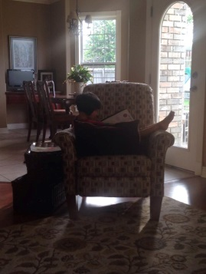

Happy Birthday to Dana Lilly Dessesaure - June 27
Dana Lilly Dessesaure:
Thank you all for your birthday wishes.

Chris Cotton:
Bobby Womack told it like it is here what I'm telling you there aren't many that have the ability to say it even though it could be offensive but not offend- (6/28)

Wytaine Smith:
Ol' Bobby RIP!!! "If you think you 're lonely now"


More Quotes- continued

Deborah Pryor-Fuller
These Kermit the frog meme's are killing me! (6/28)


William Muckleroy
Taking dad out for a steak dinner...feeling grateful to be able to

Cameron Murray:
Food in the Bahamas has been surprisingly good. Cecilia had the rack of lamb.

Clyde Boyd:
There's so much negativity happening in the world locally and nationally.
I'm requesting for everyone to come up with a positive word and post it.
You don't have to elaborate, just one word. I will start with my positive.
" Encouraging"

Harvey Boyd-
Happy Birthday to Harvey Boyd - June 28
Recent Pictures of our Classmates in action
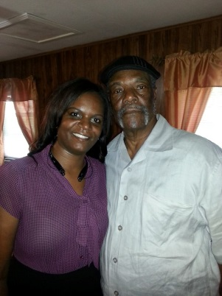



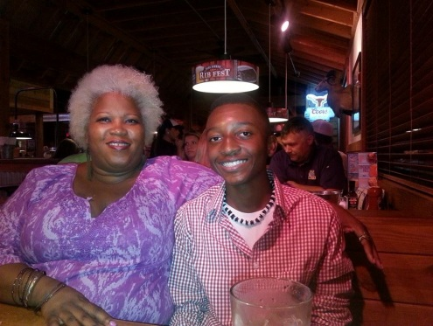


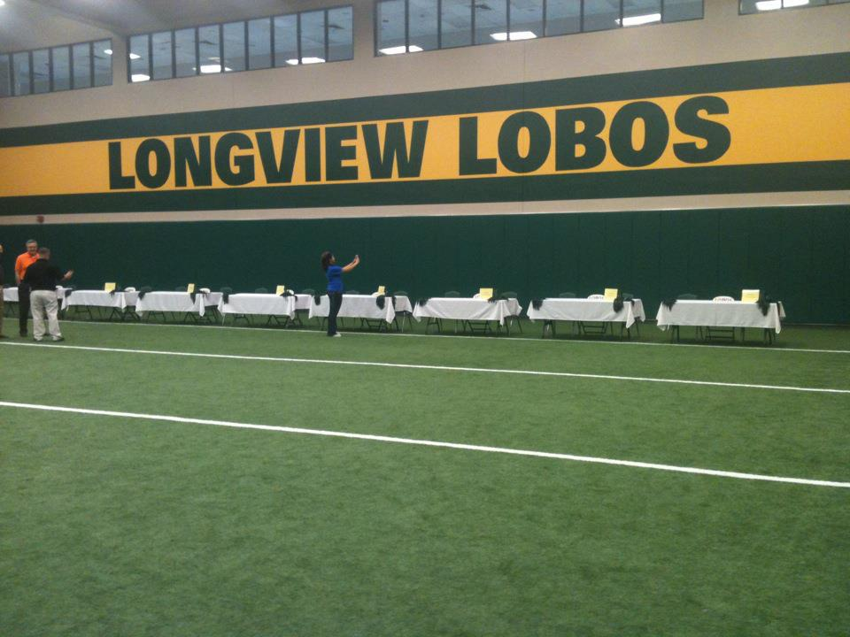


Clockwise from top left: 1. Cheryl Canada
2. Kirt Villyard
3. Kim Russell-Brown
4. Dana Lilly-Dessesaure
5. Wray Wade and Marcus Williams
6. Deborah Pryor-Fuller
7. Marcus Williams

CHECK OUT THESE LINKS:

The Lobo Class of 1986 Webpage
THE BEST CLASS EVER!

http://www.acedwardslobos86.com/LOBO86/Class86.html

Cedric E. Tales of the House Rocker Blog


http://cedric-e.blogspot.com/

If anyone has any news or announcements they would like to see in The Class of 86 News Journal, please send these to:
cedric@acedwardslobos86.com

And, if anyone can think of a better name to give our little newsletter, please send in any suggestions to the above address- (But if you like the name- The Class of 86 News Journal- let me know that, too!)

Have a great and blessed month!

